ANTI SOCIAL BEHAVIOUR COMPLAINT FORM
Strictly Confidential
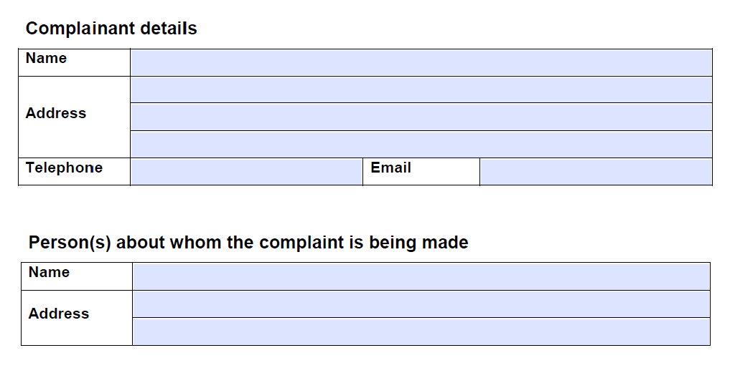

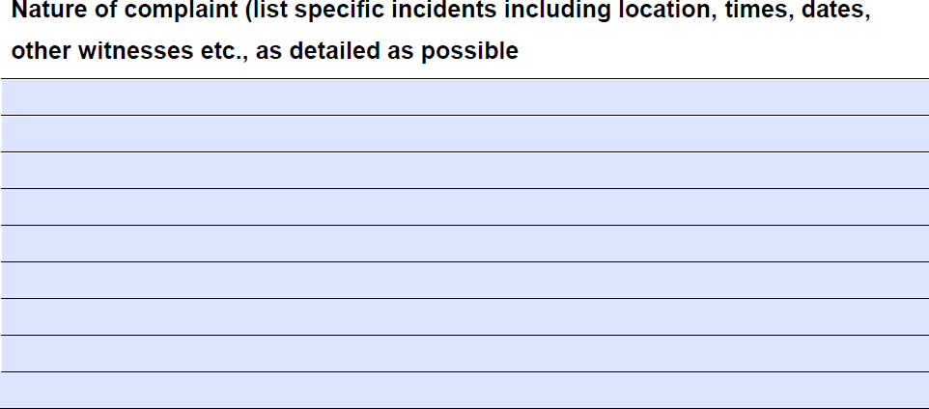

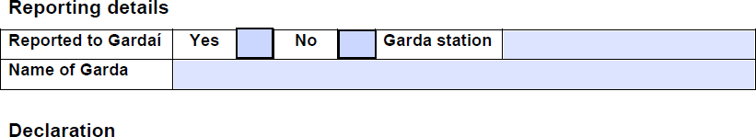
I hereby declare that the foregoing information I have supplied to TORC Sustainable Housing is truthful and accurate.
I Agree to the information on this this form being used by TORC Sustainable Housing as part of evidence and agree that they can follow up on complaint accordingly

Signature Date

Return completed forms to:
TORC Sustainable Housing – 1 Empress Place, Summerhill North, Cork
Email: info@torcsustainablehousing.ie

